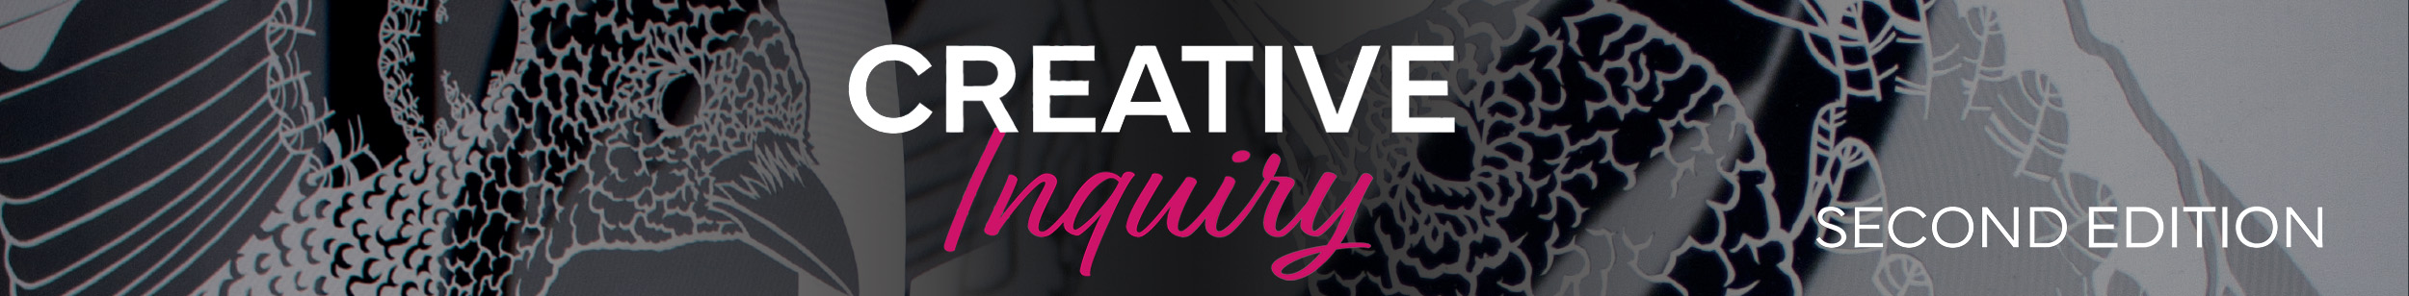1.3 Student activity
Visual Art = creative problem solving

Visual Art challenges you to stretch beyond your current knowledge and art experiences as you solve visual problems. A visual problem is like any other challenge; however, it involves developing and implementing ideas into visual expression that create and communicate meaning for an audience.

Creative Inquiry Second Edition presents case studies of contemporary artists through each concept or unit. By investigating and researching diverse artists, art practices and artworks, you will learn how artists react to stimulus and generate innovative solutions to visual problems. Considering the ideas and approaches of other artists will inspire your own art practice and develop your communication as an artist and an audience member.

innovative new and original for the context of learning; introducing new ideas through the combination of research and reflection; original and creative in thinking

eX de Medici

eX de Medici is an Australian artist and tattooist. She has an ongoing concern with the value and fragility of life, global affairs, greed, commerce, conflict and death. Her interest in science, particularly string theory, is referenced in her watercolour painting, The theory of everything, 2005. String theory is a mathematical idea in Physics that posits the interrelationship of all forces and matter.

Inquiry learning

To understand how eX de Medici has responded to a visual problem, investigate these links:
- the QAGOMA blog post, Something wicked this way comes
- and view the QAGOMA video, eX de Medici discusses her art practice & ‘The theory of everything’

- What visual problem did eX de Medici pose in The theory of everything?
- How did she generate solutions to her visual problem?
- What stimulus did eX de Medici react to?
- What ideas, information, media, techniques and processes were considered by the artist?
- What does eX de Medici communicate about contemporary identity?
- Brainstorm and discuss ideas for an artwork inspired by The theory of everything.

